SpringBoot整合SpringData JPA

创建项目并添加依赖
<project xmlns="http://maven.apache.org/POM/4.0.0" xmlns:xsi="http://www.w3.org/2001/XMLSchema-instance"
xsi:schemaLocation="http://maven.apache.org/POM/4.0.0 http://maven.apache.org/xsd/maven-4.0.0.xsd">
<modelVersion>4.0.0</modelVersion>
<parent>
<groupId>org.springframework.boot</groupId>
<artifactId>spring-boot-starter-parent</artifactId>
<version>1.5.10.RELEASE</version>
</parent>
<groupId>com.bjsxt</groupId>
<artifactId>01-spring-data-jpa</artifactId>
<version>0.0.1-SNAPSHOT</version>

<properties>
<java.version>1.8</java.version>
</properties>

<dependencies>
<!-- springBoot的启动器 -->
<dependency>
<groupId>org.springframework.boot</groupId>
<artifactId>spring-boot-starter-web</artifactId>
</dependency>
<!-- jpa的启动器 -->
<dependency>
<groupId>org.springframework.boot</groupId>
<artifactId>spring-boot-starter-data-jpa</artifactId>
</dependency>

<!-- mysql -->
<dependency>
<groupId>mysql</groupId>
<artifactId>mysql-connector-java</artifactId>
</dependency>

<!-- druid连接池 -->
<dependency>
<groupId>com.alibaba</groupId>
<artifactId>druid</artifactId>
<version>1.0.9</version>
</dependency>
<dependency>
<groupId>org.projectlombok</groupId>
<artifactId>lombok</artifactId>
</dependency>
<!-- junit的启动器 -->
<dependency>
<groupId>org.springframework.boot</groupId>
<artifactId>spring-boot-starter-test</artifactId>
</dependency>
</dependencies>
</project>

配置application.properties
spring.datasource.driver-class-name=com.mysql.jdbc.Driver
spring.datasource.url=jdbc:mysql://localhost:3306/springdata
spring.datasource.username=root
spring.datasource.password=1111
spring.datasource.type=com.alibaba.druid.pool.DruidDataSource

#正向工程 自动创建表
spring.jpa.hibernate.ddl-auto=update
#显示执行的 SQL
spring.jpa.show-sql=true

创建实体bean
@Entity//表示当前类是和表对应的实体bean
@Table(name="t_users")//对应的表名
public class Users {

@Id//主键
@GeneratedValue(strategy=GenerationType.IDENTITY)// strategy:策略 Generation:产生主键生成策略
@Column(name="id")//列名
private Integer id;

@Column(name="name")//列名
private String name;

@Column(name="age")//列名
private Integer age;

@Column(name="address")//列名
private String address;

public Integer getId() {
return id;
}

public void setId(Integer id) {
this.id = id;
}

public String getName() {
return name;
}

public void setName(String name) {
this.name = name;
}

public Integer getAge() {
return age;
}

public void setAge(Integer age) {
this.age = age;
}

public String getAddress() {
return address;
}

public void setAddress(String address) {
this.address = address;
}

@Override
public String toString() {
return "Users [id=" + id + ", name=" + name + ", age=" + age + ", address=" + address + "]";
}

}

创建dao接口
/**
* 参数一 T :当前需要映射的实体
* 参数二 ID :当前映射的实体中的OID的类型
*
*/
public interface UsersRepository extends JpaRepository<Users,Integer> {

}

测试
1、添加依赖
<!-- 测试工具的启动器 -->
<dependency>
<groupId>org.springframework.boot</groupId>
<artifactId>spring-boot-starter-test</artifactId>
</dependency>

2、创建启动类
@SpringBootApplication
public class App {

public static void main(String[] args) {
SpringApplication.run(App.class, args);
}
}

3、创建测试类
/**
* 测试类
*/
@RunWith(SpringJUnit4ClassRunner.class)
@SpringBootTest(classes=App.class)
public class UsersRepositoryTest {

@Autowired
private UsersRepository usersRepository;

@Test
public void testSave(){
Users users = new Users();
users.setAddress("北京市海淀");
users.setAge(20);
users.setName("张三");
this.usersRepository.save(users);//调用JpaRepository中的方法
}
}

Spring Data JPA的接口继承结构
Repository:
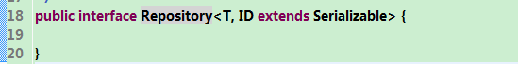
CrudRepository:
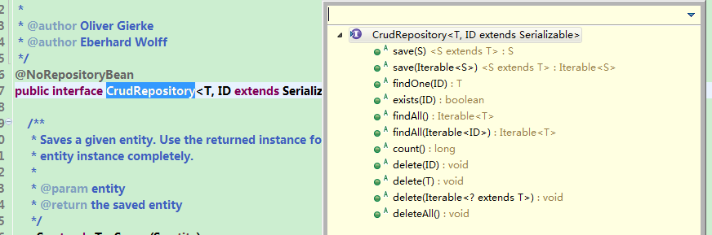

PagingAndSortingRepository:
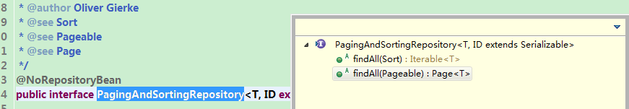

JpaRepository：
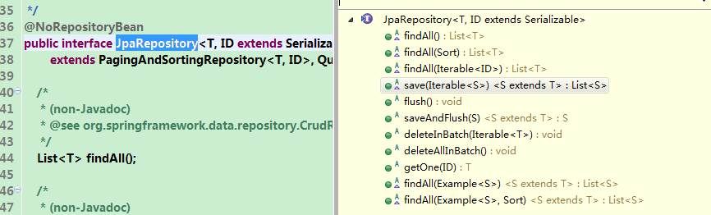

JpaSpecificationExecutor：
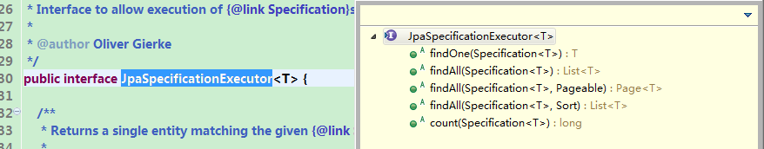
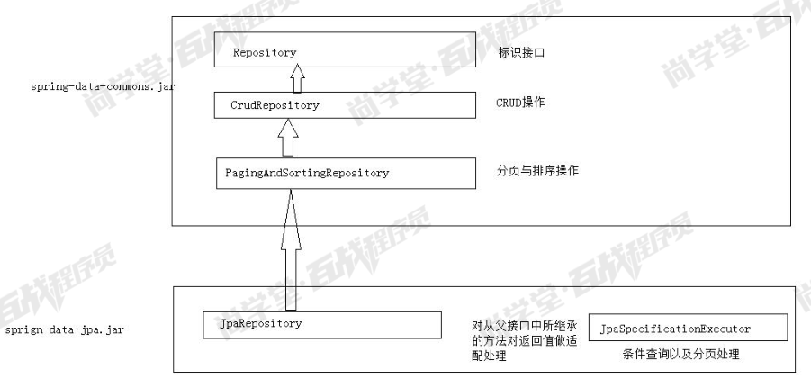

Spring Data JPA的运行原理
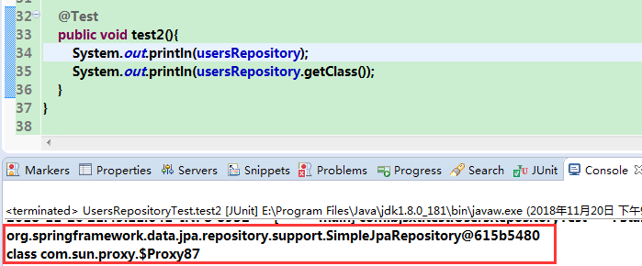
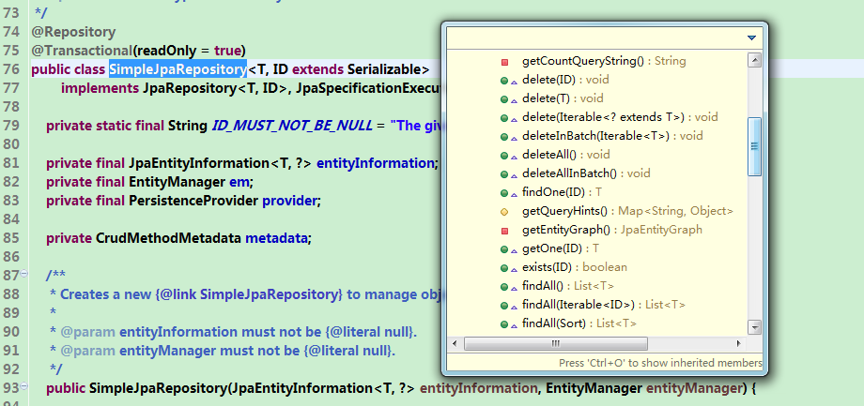
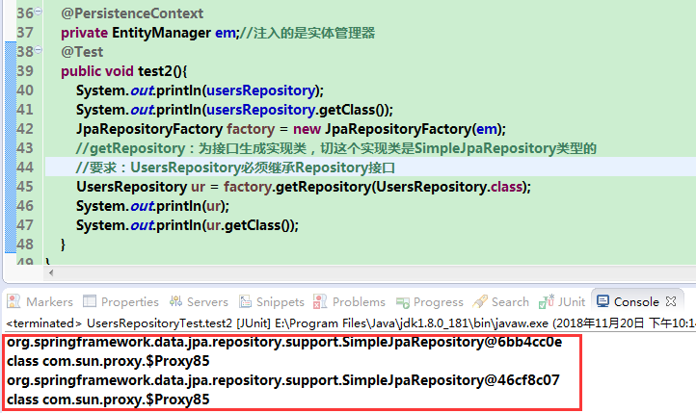

Repository 接口
Repository 接口是 Spring Data JPA 中为我我们提供的所有接口中的顶层接口
Repository 提供了两种查询方式的支持
1）基于方法名称命名规则查询
2）基于@Query 注解查询

方法名称命名规则查询

规则：
findBy(关键字)+属性名称(属性名称的首字母大写)+查询条件(首字母大写)
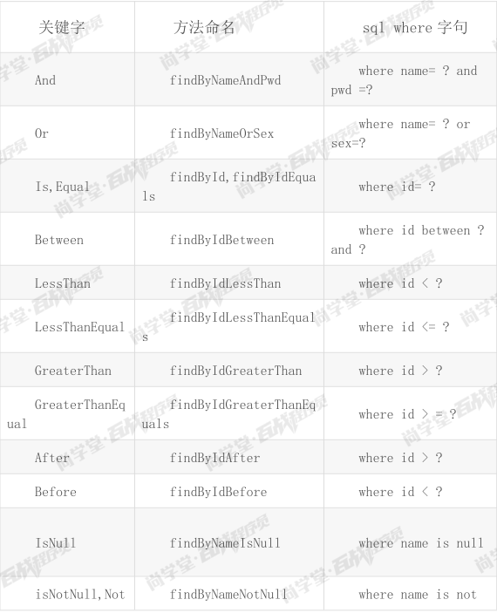
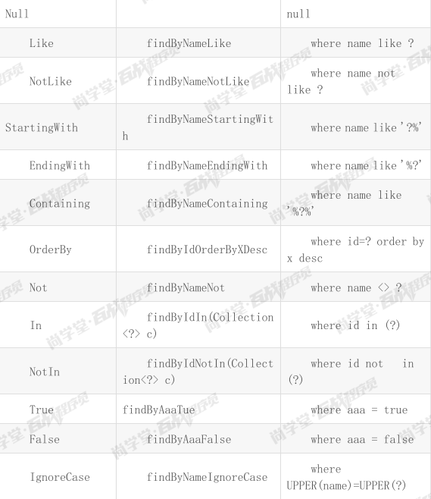

创建接口
/**
* Repository接口的方法名称命名查询
*/
public interface UsersRepositoryByName extends Repository<Users, Integer> {

//方法的名称必须要遵循驼峰式命名规则。findBy(关键字)+属性名称(首字母要大写)+查询条件(首字母大写)
List<Users> findByName(String name);

List<Users> findByNameAndAge(String name,Integer age);

List<Users> findByNameLike(String name);
}

测试类
/**
* 测试类
*/
@RunWith(SpringJUnit4ClassRunner.class)
@SpringBootTest(classes=App.class)
public class UsersRepositoryTest {

@Autowired
private UsersRepositoryByName usersRepositoryByName;

@Test
public void test1(){
List<Users> userss = usersRepositoryByName.findByName("张三");
for (Users users : userss) {
System.out.println(users.toString());
}
}

@Test
public void test2(){
List<Users> userss = usersRepositoryByName.findByNameAndAge("张三", 20);
for (Users users : userss) {
System.out.println(users.toString());
}
}

@Test
public void test3(){
List<Users> userss = usersRepositoryByName.findByNameLike("张%");
for (Users users : userss) {
System.out.println(users.toString());
}
}
}

基于@Query注解的查询

通过 JPQL语句查询
JPQL：通过 Hibernate 的 HQL 演变过来的。他和 HQL 语法及其相似。
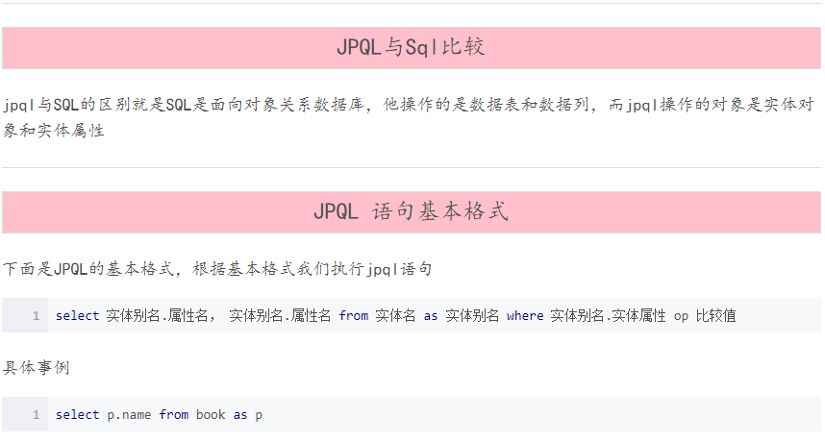

创建接口
/**
* Repository @Query
*/
public interface UsersRepositoryQueryAnnotation extends Repository<Users, Integer> {
@Query("from Users where name = ?")
List<Users> queryByNameUseJPQL(String name);

@Query("from Users where name like ?")
List<Users> queryUserByLikeNameUseJPQL(String name);

@Query(value="select * from t_users where name = ?",nativeQuery=true)
List<Users> queryByNameUseSQL(String name);

@Query("update Users set name = ? where id = ?")
@Modifying //需要执行一个更新操作
void updateUsersNameById(String name,Integer id);
}

测试类
/**
* 测试类
*/
@RunWith(SpringJUnit4ClassRunner.class)
@SpringBootTest(classes = App.class)
public class UsersRepositoryTest {

@Autowired
private UsersRepositoryQueryAnnotation usersRepositoryQueryAnnotation;

/**
* 测试@Query 查询 JPQL
*/
@Test
public void test4() {
List<Users> list = this.usersRepositoryQueryAnnotation.queryByNameUseJPQL("张三");
for (Users users : list) {
System.out.println(users);
}
}

/**
* 测试@Query 查询 JPQL
*/
@Test
public void test5() {
List<Users> list = this.usersRepositoryQueryAnnotation.queryUserByLikeNameUseJPQL("王%");
for (Users users : list) {
System.out.println(users);
}
}

/**
* 测试@Query 查询SQL
*/
@Test
public void test6() {
List<Users> list = this.usersRepositoryQueryAnnotation.queryByNameUseSQL("张三");
for (Users users : list) {
System.out.println(users);
}
}

/**
* Repository--@Query测试
*/
@Test
@Transactional //@Transactional与@Test 一起使用时 事务是自动回滚的。
@Rollback(false) //取消自动回滚
public void testUpdateUsersNameById() {
this.usersRepositoryQueryAnnotation.updateUsersNameById("张三三", 1);
}
}

CrudRepository接口

创建接口
/**
* CrudRepository接口
*
*
*/
public interface UsersCrudRepository extends CrudRepository<Users, Integer> {

}

测试类
/**
* 测试类
*/
@RunWith(SpringJUnit4ClassRunner.class)
@SpringBootTest(classes = App.class)
public class UsersRepositoryCrudRepositoryTest {

@Autowired
private UsersRepositoryCrudRepository usersRepositoryCrudRepository;

/**
* CrudRepository测试
*/
@Test
public void testCrudRepositorySave() {
Users user = new Users();
user.setAddress("天津");
user.setAge(32);
user.setName("张三丰");
this.usersRepositoryCrudRepository.save(user);
}

/**
* CrudRepository测试
*/
@Test
public void testCrudRepositoryUpdate() {
Users user = new Users();
user.setId(4);
user.setAddress("南京");
user.setAge(40);
user.setName("张三丰");
this.usersRepositoryCrudRepository.save(user);
}

/**
* CrudRepository测试
*/
@Test
public void testCrudRepositoryFindOne() {
Users users = this.usersRepositoryCrudRepository.findOne(4);
System.out.println(users);
}

/**
* CrudRepository测试
*/
@Test
public void testCrudRepositoryFindAll() {
List<Users> list = (List<Users>)this.usersRepositoryCrudRepository.findAll();
for (Users users : list) {
System.out.println(users);
}
}

/**
* CrudRepository测试
*/
@Test
public void testCrudRepositoryDeleteById() {
this.usersRepositoryCrudRepository.delete(4);
}
}

PagingAndSortingRepository接口

创建接口
/**
*
*PagingAndSortingRepository接口
*
*/
public interface UsersRepositoryPagingAndSorting extends PagingAndSortingRepository<Users,Integer> {

}

测试类
/**
* 测试类
*/
@RunWith(SpringJUnit4ClassRunner.class)
@SpringBootTest(classes = App.class)
public class UsersRepositoryPagingAndSortingTest {

@Autowired
private UsersRepositoryPagingAndSorting usersRepositoryPagingAndSorting;

/**
* PagingAndSortingRepository 排序测试
*/
@Test
public void testPagingAndSortingRepositorySort() {
//Order 定义排序规则
Order order = new Order(Direction.DESC,"id");
//Sort对象封装了排序规则
Sort sort = new Sort(order);
List<Users> list = (List<Users>)this.usersRepositoryPagingAndSorting.findAll(sort);
for (Users users : list) {
System.out.println(users);
}
}

/**
* PagingAndSortingRepository 分页测试
*/
@Test
public void testPagingAndSortingRepositoryPaging() {
//Pageable:封装了分页的参数，当前页，每页显示的条数。注意：他的当前页是从0开始。
//PageRequest(page,size) page:当前页。size:每页显示的条数
Pageable pageable = new PageRequest(1, 2);
Page<Users> page = this.usersRepositoryPagingAndSorting.findAll(pageable);
System.out.println("总条数："+page.getTotalElements());
System.out.println("总页数"+page.getTotalPages());
List<Users> list = page.getContent();
for (Users users : list) {
System.out.println(users);
}
}

/**
* PagingAndSortingRepository 排序+分页
*/
@Test
public void testPagingAndSortingRepositorySortAndPaging() {

Sort sort = new Sort(new Order(Direction.DESC, "id"));

Pageable pageable = new PageRequest(1, 2, sort);

Page<Users> page = this.usersRepositoryPagingAndSorting.findAll(pageable);
System.out.println("总条数："+page.getTotalElements());
System.out.println("总页数"+page.getTotalPages());
List<Users> list = page.getContent();
for (Users users : list) {
System.out.println(users);
}
}
}

JpaRepository 接口
JpaRepository 接口是我们开发时使用的最多的接口。其特点是可以帮助我们将其他接口的方法的返回值做适配处理。可以使得我们在开发时更方便的使用这些方法。

创建接口
/**
* 参数一 T :当前需要映射的实体
* 参数二 ID :当前映射的实体中的OID的类型
*
*/
public interface UsersRepository extends JpaRepository<Users,Integer>{
}

测试类
/**
* 测试类
*/
@RunWith(SpringJUnit4ClassRunner.class)
@SpringBootTest(classes = App.class)
public class UsersJpaRepositoryTest {

@Autowired
private UsersJpaRepository usersJpaRepository;
/**
* JapRepository 排序测试
*/
@Test
public void testJpaRepositorySort() {
//Order 定义排序规则
Order order = new Order(Direction.DESC,"id");
//Sort对象封装了排序规则
Sort sort = new Sort(order);
List<Users> list = this.usersJpaRepository.findAll(sort);
for (Users users : list) {
System.out.println(users);
}
}
}

JpaSpecificationExecutor 接口
该接口主要提供了多条件查询的支持，并且可以在查询中添加分页与排序
注意：JpaSpecificationExecutor接口
  - 与以上接口没有关系，完全独立。
  - :不能单独使用，需要配合着 jpa 中的其他接口一起使用

创建接口
/**
*
*JpaSpecificationExecutor
*
*/
public interface UsersSpecificationRepository extends JpaRepository<Users, Integer>, JpaSpecificationExecutor<Users> {

}

单条件测试
/**
* 测试类
*/
@RunWith(SpringJUnit4ClassRunner.class)
@SpringBootTest(classes = App.class)
public class UsersRepositorySpecificationTest {

@Autowired
private UsersRepositorySpecification usersRepositorySpecification;

/**
* JpaSpecificationExecutor 单条件测试
*/
@Test
public void testJpaSpecificationExecutor1() {

/**
* Specification<Users>:用于封装查询条件
*/
Specification<Users> spec = new Specification<Users>() {

//Predicate:封装了 单个的查询条件
/**
* Root<Users> root:查询对象的属性的封装。
* CriteriaQuery<?> query：封装了我们要执行的查询中的各个部分的信息，select from order by
* CriteriaBuilder cb:查询条件的构造器。定义不同的查询条件
*/
@Override
public Predicate toPredicate(Root<Users> root, CriteriaQuery<?> query, CriteriaBuilder cb) {
// where name = '张三三'
/**
* 参数一：查询的条件属性
* 参数二：条件的值
*/
Predicate pre = cb.equal(root.get("name"), "张三三");
return pre;
}
};
List<Users> list = this.usersRepositorySpecification.findAll(spec);
for (Users users : list) {
System.out.println(users);
}
}

}

多条件测试
/**
* JpaSpecificationExecutor 多条件测试
*/
@Test
public void testJpaSpecificationExecutor2() {

/**
* Specification<Users>:用于封装查询条件
*/
Specification<Users> spec = new Specification<Users>() {

//Predicate:封装了 多个的查询条件
/**
* Root<Users> root:查询对象的属性的封装。
* CriteriaQuery<?> query：封装了我们要执行的查询中的各个部分的信息，select from order by
* CriteriaBuilder cb:查询条件的构造器。定义不同的查询条件
*/
@Override
public Predicate toPredicate(Root<Users> root, CriteriaQuery<?> query, CriteriaBuilder cb) {
// where name = '张三三' and age = 20
List<Predicate> list = new ArrayList<>();
list.add(cb.equal(root.get("name"),"张三三"));
list.add(cb.equal(root.get("age"),20));
Predicate[] arr = new Predicate[list.size()];
return cb.and(list.toArray(arr));
//Predicate predicate = cb.and(cb.equal(root.get("name"),"世凯"),
cb.equal(root.get("age"), 18));
//return predicate;
}
};
List<Users> list = this.usersRepositorySpecification.findAll(spec);
for (Users users : list) {
System.out.println(users);
}
}

多条件测试二
/**
* JpaSpecificationExecutor 多条件测试第二种写法
*/
@Test
public void testJpaSpecificationExecutor3() {

/**
* Specification<Users>:用于封装查询条件
*/
Specification<Users> spec = new Specification<Users>() {

//Predicate:封装了 单个的查询条件
/**
* Root<Users> root:查询对象的属性的封装。
* CriteriaQuery<?> query：封装了我们要执行的查询中的各个部分的信息，select from order by
* CriteriaBuilder cb:查询条件的构造器。定义不同的查询条件
*/
@Override
public Predicate toPredicate(Root<Users> root, CriteriaQuery<?> query, CriteriaBuilder cb) {
// where name = '张三三' and age = 20
/*
List<Predicate> list = new ArrayList<>();
list.add(cb.equal(root.get("name"),"张三三"));
list.add(cb.equal(root.get("age"),20));
Predicate[] arr = new Predicate[list.size()];
cb.and(cb.equal(root.get("name"),"张三三"),cb.equal(root.get("age"),20)
*/
//(name = '张三' and age = 20) or id = 2
return cb.or(cb.and(cb.equal(root.get("name"),"张三三"),
cb.equal(root.get("age"),20)),cb.equal(root.get("id"), 2));
}
};

Sort sort = new Sort(new Order(Direction.DESC,"id"));
List<Users> list = this.usersRepositorySpecification.findAll(spec,sort);
for (Users users : list) {
System.out.println(users);
}
}

分页
/**
* JpaSpecificationExecutor 需求：查询张姓用户，并且做分页处理
*/
@Test
public void testJpaSpecificationExecutor4() {

// 条件
Specification<Users> spec = new Specification<Users>() {
@Override
public Predicate toPredicate(Root<Users> root, CriteriaQuery<?> query,
CriteriaBuilder cb) {
return cb.like(root.get("name").as(String.class), "张%");
}
};
//排序等定义
Sort sort = new Sort(Direction.DESC,"id");
//分页的定义
Pageable pageable = new PageRequest(0,5, sort);
Page<Users> page = this.usersRepositorySpecification.findAll(spec, pageable);
System.out.println("总条数：" + page.getTotalElements());
System.out.println("总页数：" + page.getTotalPages());
List<Users> list = page.getContent();
for (Users users : list) {
System.out.println(users);
}
}

关联查询操作

一对一关联查询
需求：用户与角色的一对一的关联关系
用户：一方
角色：一方

创建Roles实体
@Entity
@Table(name="t_roles")
public class Roles {
@Id
@GeneratedValue(strategy=GenerationType.IDENTITY)
@Column(name="roleid")
private Integer roleid;

@Column(name="rolename")
private String rolename;

public Integer getRoleid() {
return roleid;
}

public void setRoleid(Integer roleid) {
this.roleid = roleid;
}

public String getRolename() {
return rolename;
}

public void setRolename(String rolename) {
this.rolename = rolename;
}
@Override
public String toString() {
return "Roles [roleid=" + roleid + ", rolename=" + rolename + "]";
}
}

创建 Users实体
@Entity
@Table(name = "t_users")
public class Users {

@Id
@GeneratedValue(strategy = GenerationType.IDENTITY)
@Column(name = "id")
private Integer id;

@Column(name = "name")
private String name;

@Column(name = "age")
private Integer age;

@Column(name = "address")
private String address;

@OneToOne(cascade = CascadeType.PERSIST) //级联保存roles
// @JoinColumn:维护外键
@JoinColumn(name = "roleid")
private Roles roles;

public Integer getId() {
return id;
}

public void setId(Integer id) {
this.id = id;
}

public String getName() {
return name;
}

public void setName(String name) {
this.name = name;
}

public Integer getAge() {
return age;
}

public void setAge(Integer age) {
this.age = age;
}

public String getAddress() {
return address;
}

public void setAddress(String address) {
this.address = address;
}

public Roles getRoles() {
return roles;
}

public void setRoles(Roles roles) {
this.roles = roles;
}

@Override
public String toString() {
return "Users [id=" + id + ", name=" + name + ", age=" + age + ", address=" + address + ", roles=" + roles
+ "]";
}
}

测试
/**
* 一对一关联关系测试
*/
@RunWith(SpringJUnit4ClassRunner.class)
@SpringBootTest(classes=App.class)
public class OneToOneTest {

@Autowired
private UsersRepository usersRepository;

/**
* 一对一关联关系的添加
*/
@Test
public void testSave(){
//创建一个用户
Users users = new Users();
users.setAddress("天津");
users.setAge(32);
users.setName("小刚");

//创建一个角色
Roles roles = new Roles();
roles.setRolename("管理员");

users.setRoles(roles);
//保存
this.usersRepository.save(users);
}

/**
* 一对一关联关系的查询
*/
@Test
public void testFind(){
Users findOne = this.usersRepository.findOne(1);
System.out.println(findOne);
}
}

双向一对一
@Entity
@Table(name = "tb_user")
@Data
public class User {
@Column(name = "age")
private Integer age;
@Column(name = "id")
@Id
@GeneratedValue(strategy = GenerationType.IDENTITY)
private Integer id;
@Column(name = "name")
private String name;
@Column(name = "address")
private String address;
@JoinColumn(name = "roleId")
@OneToOne(cascade = CascadeType.PERSIST)//级联保存
private Rolse rolse;
@Override
public String toString() {
return "User{" +
"age=" + age +
", id=" + id +
", name='" + name + '\'' +
", address='" + address + '\'' +
'}';
}
}

@Data
@Entity
@Table(name = "tb_rolse")
public class Rolse {
@Id
@Column(name = "role_id")
@GeneratedValue(strategy=GenerationType.IDENTITY)
private Integer roleId;
@Column(name = "role_name")
private String roleName;
@OneToOne(mappedBy = "rolse")//mappedBy相当于inverse的作用
private User user;
}

一对多关联查询
需求：从角色到用户的一对多的关联关系
角色：一方
用户：多方

创建接口
/**
* 参数一 T :当前需要映射的实体
* 参数二 ID :当前映射的实体中的OID的类型
*
*/
public interface RoleRepository extends JpaRepository<Roles,Integer>{

}

创建 Users实体
@Entity(name = "user")
@Table(name = "tb_user_many")
public class User {
@Column(name = "age")
private Integer age;
@Column(name = "id")
@Id
@GeneratedValue(strategy = GenerationType.IDENTITY)
private Integer id;
@Column(name = "name")
private String name;
@Column(name = "address")
private String address;
@JoinColumn(name = "roleId")
@ManyToOne(cascade = CascadeType.PERSIST)
private Rolse rolse;
@Override
public String toString() {
return "User{" +
"age=" + age +
", id=" + id +
", name='" + name + '\'' +
", address='" + address + '\'' +
'}';
}
public Integer getAge() {
return age;
}
public void setAge(Integer age) {
this.age = age;
}
public Integer getId() {
return id;
}
public void setId(Integer id) {
this.id = id;
}
public String getName() {
return name;
}
public void setName(String name) {
this.name = name;
}
public String getAddress() {
return address;
}
public void setAddress(String address) {
this.address = address;
}
public Rolse getRolse() {
return rolse;
}
public void setRolse(Rolse rolse) {
this.rolse = rolse;
}
@Override
public boolean equals(Object o) {
if (this == o) return true;
if (o == null || getClass() != o.getClass()) return false;
User user = (User) o;
return Objects.equals(age, user.age) &&
Objects.equals(id, user.id) &&
Objects.equals(name, user.name) &&
Objects.equals(address, user.address);
}
@Override
public int hashCode() {
return Objects.hash(age, id, name, address);
}
}

创建 Roles 实体
@Data
@Entity
@Table(name = "tb_rolse_one")
public class Rolse {
@Id
@Column(name = "role_id")
@GeneratedValue(strategy=GenerationType.IDENTITY)
private Integer roleId;
@Column(name = "role_name")
private String roleName;
//@OneToMany(mappedBy = "rolse",fetch = FetchType.EAGER)//mappedBy相当于inverse的作用将管理交给一方
@OneToMany(mappedBy = "rolse",fetch = FetchType.LAZY)//mappedBy相当于inverse的作用将管理交给一方
private Set<User> user;
}

测试
/**
* 一对多关联关系测试
*/
@RunWith(SpringJUnit4ClassRunner.class)
@SpringBootTest(classes = {Application.class})
public class JpaTest {
@Autowired
private UsersRepository usersRepository;
@Autowired
private RolseRepository rolseRepository;
@Test
public void testSave(){
Rolse r1 = new Rolse();
r1.setRoleName("董事事长");
Rolse r2 = new Rolse();
r2.setRoleName("秘书");
User ym = new User();
ym.setAddress("延津");
ym.setName("ym");
ym.setAge(24);
ym.setRolse(r2);
User yy = new User();
yy.setAddress("郑州");
yy.setName("yy");
yy.setAge(22);
yy.setRolse(r2);
List<User> us = new ArrayList<User>();
us.add(ym);
us.add(yy);
usersRepository.save(us);
}
@Test
public void testSelect()throws Exception{
Rolse rolse = rolseRepository.findOne(3);
System.out.println(rolse);
System.out.println(rolse.getUser());
}

补充:fetch = FetchType.LAZY为懒加载时查询user时会宝异常须在方法上家注解
org.hibernate.LazyInitializationException: failed to lazily initialize a collection of role: com.sxt.pojo.Rolse.user, could not initialize proxy - no Session

@Test
@Transactional
public void testSelect()throws Exception{
Rolse rolse = rolseRepository.findOne(3);
System.out.println(rolse);
System.out.println(rolse.getUser());
}

多对多关联查询
需求：一个角色可以拥有多个菜单，一个菜单可以分配多个角色。多对多的关联关系
角色：多方
菜单：多方

创建Menus实体
@Entity(name = "menus")
@Table(name = "tb_menus")
public class Menus {
@Id
@GeneratedValue(strategy= GenerationType.IDENTITY)
@Column(name="menus_id")
private Integer menusId;
@Column(name="menus_name")
private String menusName;
@Column(name="menus_url")
private String menusUrl;
@Column(name="fatherId")
private Integer fatherId;
//将关系的操作交给对方操作
@ManyToMany(mappedBy = "menus")
private Set<Rolse> rolses = new HashSet<Rolse>();
@Override
public String toString() {
return "Menus{" +
"menusId=" + menusId +
", menusName='" + menusName + '\'' +
", menusUrl='" + menusUrl + '\'' +
", fatherId=" + fatherId +
'}';
}
public Integer getMenusId() {
return menusId;
}
public void setMenusId(Integer menusId) {
this.menusId = menusId;
}
public String getMenusName() {
return menusName;
}
public void setMenusName(String menusName) {
this.menusName = menusName;
}
public String getMenusUrl() {
return menusUrl;
}
public void setMenusUrl(String menusUrl) {
this.menusUrl = menusUrl;
}
public Integer getFatherId() {
return fatherId;
}
public void setFatherId(Integer fatherId) {
this.fatherId = fatherId;
}
public Set<Rolse> getRolses() {
return rolses;
}
public void setRolses(Set<Rolse> rolses) {
this.rolses = rolses;
}
@Override
public boolean equals(Object o) {
if (this == o) return true;
if (o == null || getClass() != o.getClass()) return false;
Menus menus = (Menus) o;
return Objects.equals(menusId, menus.menusId) &&
Objects.equals(menusName, menus.menusName) &&
Objects.equals(menusUrl, menus.menusUrl) &&
Objects.equals(fatherId, menus.fatherId);
}
@Override
public int hashCode() {
return Objects.hash(menusId, menusName, menusUrl, fatherId);
}
}

创建 Roles实体
@Entity
@Table(name = "tb_rolse_one")
public class Rolse {
@Id
@Column(name = "role_id")
@GeneratedValue(strategy=GenerationType.IDENTITY)
private Integer roleId;
@Column(name = "role_name")
private String roleName;
//@OneToMany(mappedBy = "rolse",fetch = FetchType.EAGER)//mappedBy相当于inverse的作用将管理交给一方
@OneToMany(mappedBy = "rolse",fetch = FetchType.LAZY)//mappedBy相当于inverse的作用将管理交给一方
private Set<User> user;
@ManyToMany(cascade = CascadeType.MERGE,fetch = FetchType.LAZY)
@JoinTable(name = "tb_roles_menus",joinColumns = @JoinColumn(name = "role_id"),
inverseJoinColumns = @JoinColumn(name = "menus_id"))
private Set<Menus> menus = new HashSet<Menus>();
public Integer getRoleId() {
return roleId;
}
public void setRoleId(Integer roleId) {
this.roleId = roleId;
}
public String getRoleName() {
return roleName;
}
public void setRoleName(String roleName) {
this.roleName = roleName;
}
public Set<User> getUser() {
return user;
}
public void setUser(Set<User> user) {
this.user = user;
}
public Set<Menus> getMenus() {
return menus;
}
public void setMenus(Set<Menus> menus) {
this.menus = menus;
}
@Override
public boolean equals(Object o) {
if (this == o) return true;
if (o == null || getClass() != o.getClass()) return false;
Rolse rolse = (Rolse) o;
return Objects.equals(roleId, rolse.roleId) &&
Objects.equals(roleName, rolse.roleName);
}
@Override
public int hashCode() {
return Objects.hash(roleId, roleName);
}
@Override
public String toString() {
return "Rolse{" +
"roleId=" + roleId +
", roleName='" + roleName + '\'' +
'}';
}
}

测试
@RunWith(SpringJUnit4ClassRunner.class)
@SpringBootTest(classes = {Application.class})
public class Test {
@Autowired
private RolseRepository rolseRepository;
@Autowired
private MenusRepository menusRepository;
@org.junit.Test
public void testFind() throws Exception{
Rolse one = rolseRepository.findOne(1);
System.out.println(one);
}
@org.junit.Test
@Transactional //@Transactional与@Test 一起使用时 事务是自动回滚的。
@Rollback(false) //取消自动回滚
public void testSave() throws Exception{
Rolse r1 = rolseRepository.findOne(3);
Menus me = new Menus();
me.setMenusName("部门管理");
me.setMenusUrl("/XX/XX");
me.setFatherId(0);
Menus me1 = new Menus();
me1.setMenusName("财政管理");
me1.setMenusUrl("/XX/XX");
me1.setFatherId(0);
r1.getMenus().add(me);
r1.getMenus().add(me1);
rolseRepository.save(r1);
}
}

CascadeType.PERSIST级联刷新：获取order对象里也同时也重新获取最新的items时的对象。对应EntityManager的refresh(object)方法有效。即会重新查询数据库里的最新数据

CascadeType.REFRESH级联保存：对order对象保存时也对items里的对象也会保存。对应EntityManager的presist方法
CascadeType.REMOVE级联删除：对order对象删除也对items里的对象也会删除。对应EntityManager的remove方法
CascadeType.PERSIST只有A类新增时，会级联B对象新增。若B对象在数据库存（跟新）在则抛异常（让B变为持久态）
异常
Caused by: org.hibernate.PersistentObjectException: detached entity passed to persist: com.sxt.pojo.Rolse

CascadeType.MERGE指A类新增或者变化，会级联B对象（新增或者变化）
CascadeType.REMOVE只有A类删除时，会级联删除B类；
CascadeType.ALL包含所有；
CascadeType.REFRESH：级联刷新，当多个用户同时作操作一个实体，为了用户取到的数据是实时的，在用实体中的数据之前就可以调用一下refresh()方法！

hibernate配置文件中有这么一个属性inverse，它是用来指定关联的控制方的。
inverse属性默认是false，若为false，则关联由自己控制，若为true，则关联
由对方控制。

@Transactional //@Transactional与@Test 一起使用时 事务是自动回滚的。
@Rollback(false) //取消自动回滚

